# Keyman Keyboard Usage Instructions

Please make sure that Keyman is already running in your machine. This can be seen my the small keyboard key-like icon in the taskbar.



In some cases, the icon could be hidden as shown below;

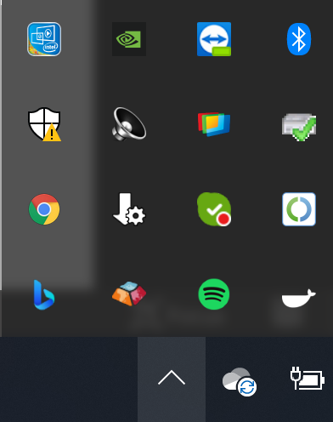

If you cannot see the icon, please start Keyman.

With Keyman running, you should be able to see the “Sharada Unicode Phonetic” and “Sharada Unicode Inscript” keyboard by clicking on the language icon (that most probably says ENG).

If you’re select Sharada inscript keyboard, you can view the onscreen keyboard from the Keyman menu.

For the phonetic keyboard, the keyboard mapping can be found under the start menu within the folder “Sharada Keyboard".

Using the language menu as shown above, set the Keyboard to “Sharada Unicode Phonetic” or “Sharada Unicode Inscript” . You can also invoke the language menu using windows key + space bar.

Open LibreOffice Writer. Unfortunately, Sharada is not yet properly supported in Microsoft Office. If you don’t have LibreOffice installed, please install it.

You can now compose text. Make sure the font is properly set as Satisar Sharada.

Sometimes, the font may revert back to something else. In this case, the text may appear as boxes. Please select the text and set the font again as “Satisar Sharada”.

You should now be able to type in Sharada without any font issues

To ensure proper legibility and to avoid overcrowding of text, please sufficiently increase the line-spacing.

